# CS 255 System Design Document Template

## UML Diagrams

### UML Use Case Diagram

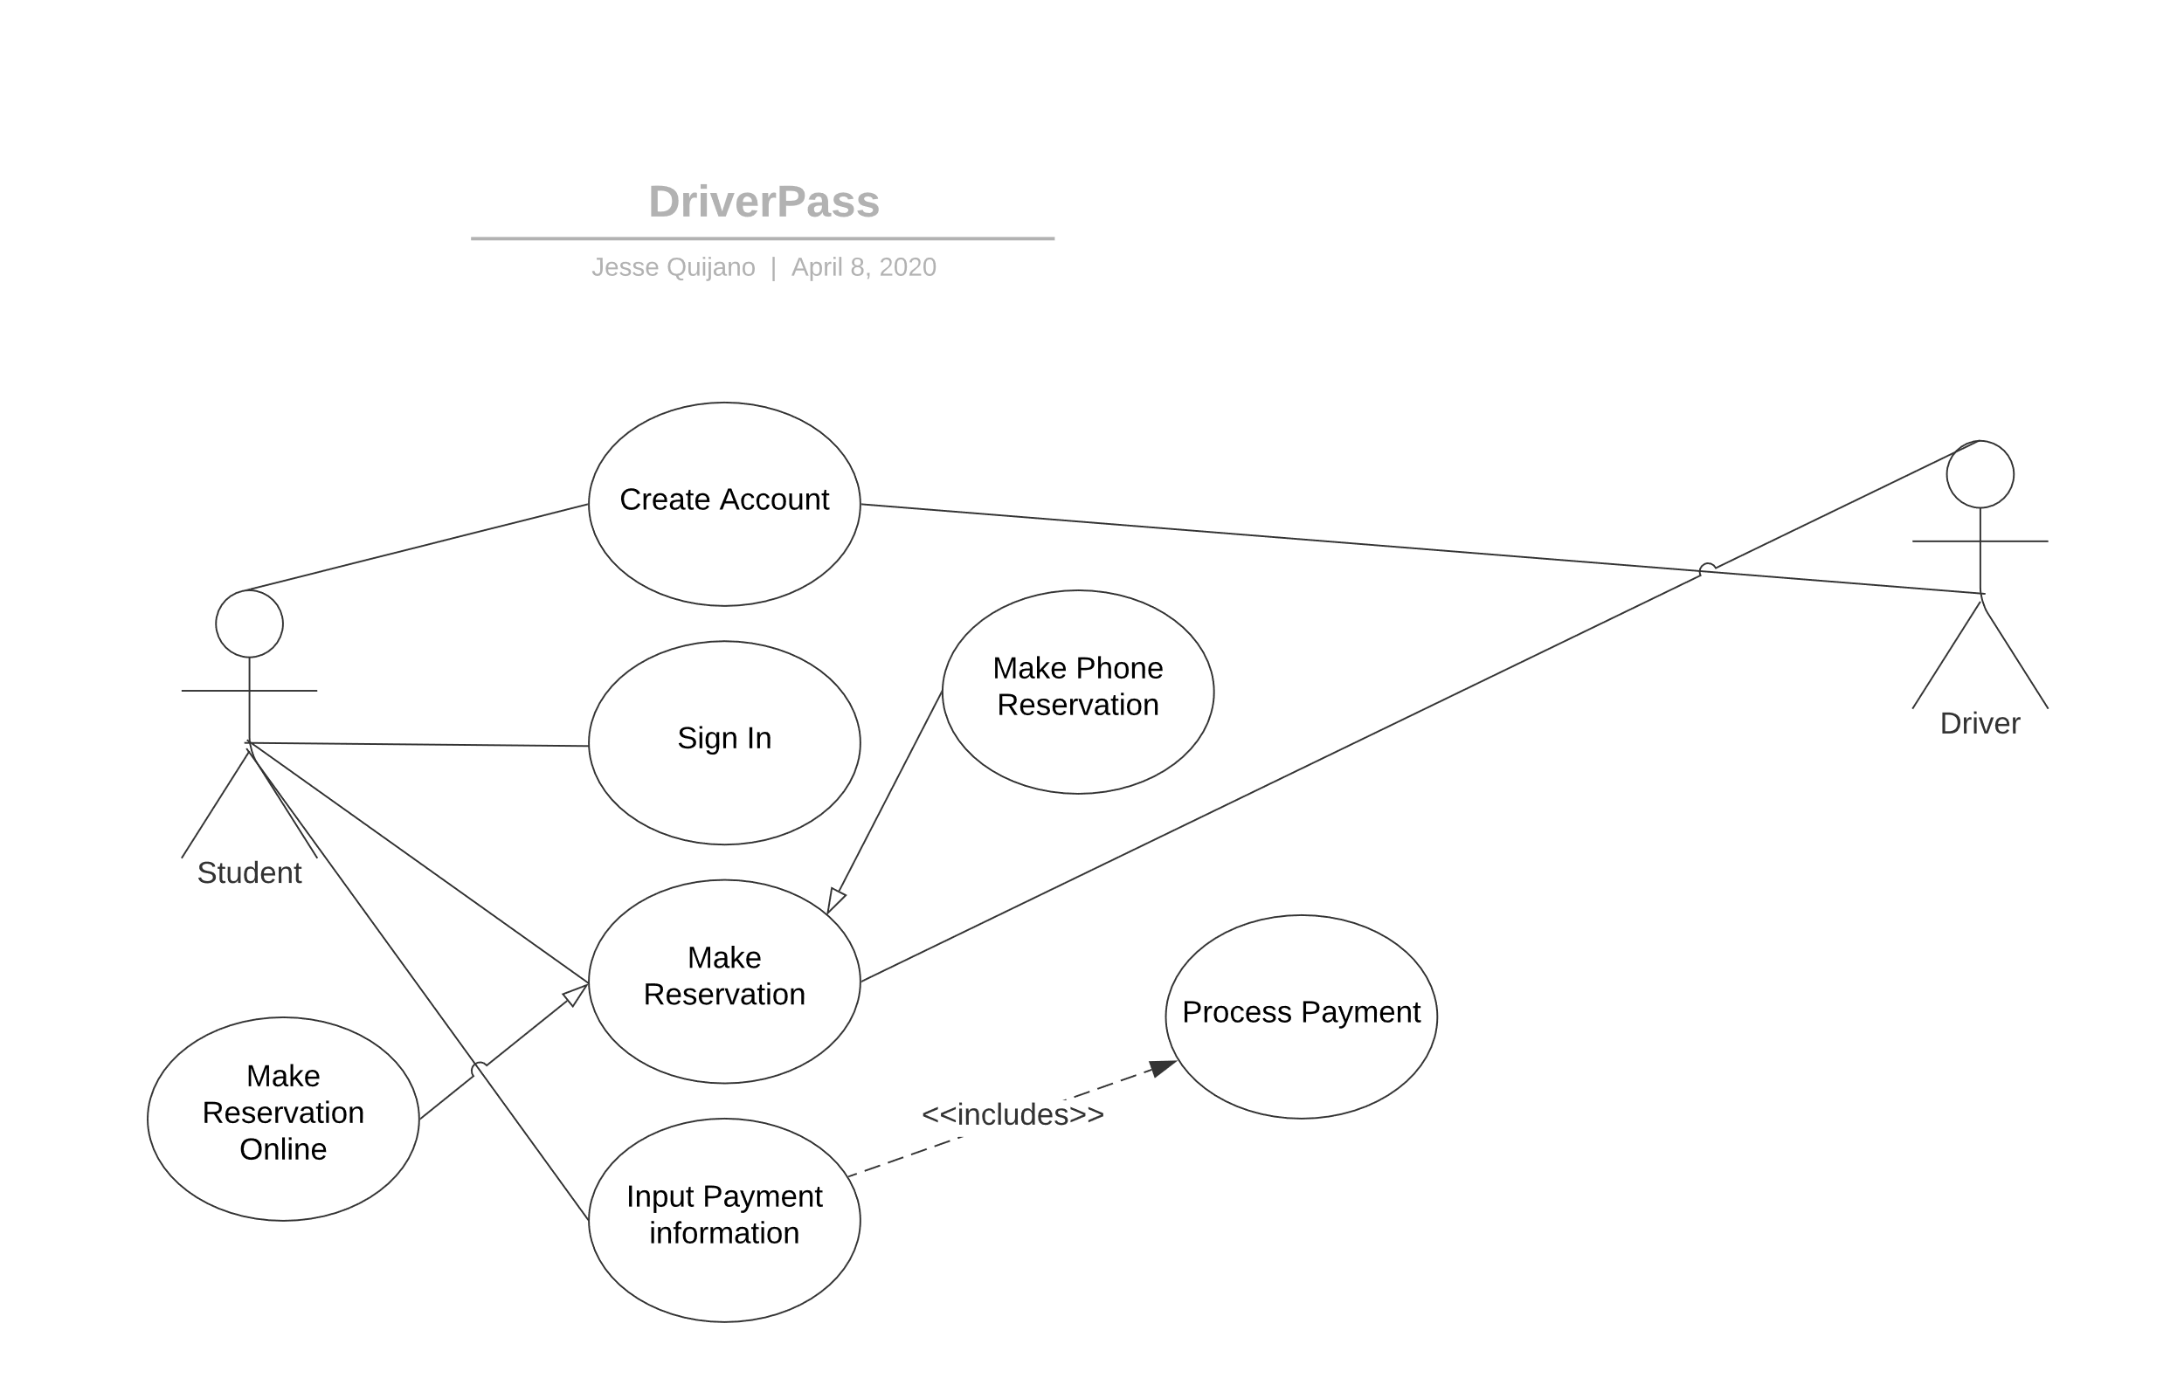

### UML Activity Diagrams

### UML Sequence Diagram

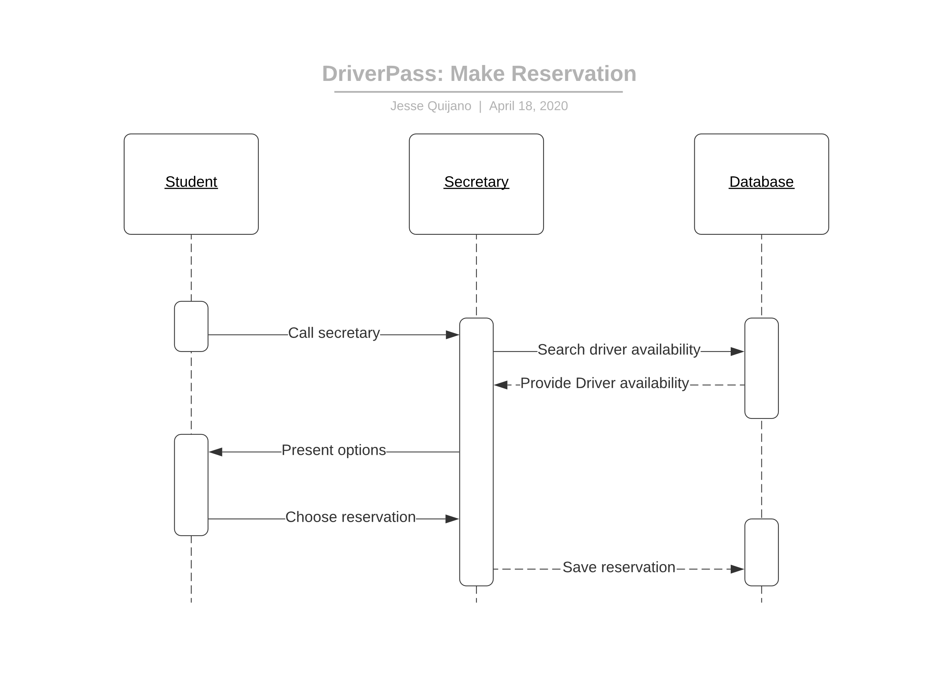

### UML Class Diagram

## Technical Requirements

For the system to function properly, we would need to start with a hosted web server. This allows for our Secretaries and Students to access the system from an off premise device. The client wants to have the server hosted with a cloud service provider. They do not want to concern themselves with security, so choosing to deploy with a cloud service provider allows the burden of physical security, and some software security, to lie with the provider. The system will also need some form of a call center. This is for secretaries to take calls from students who want to create an account in the system or to take calls from students who want to make a payment for a course. At minimum, there needs to be a single user database that holds the information for students and the packages they have purchased. There also needs to be a backend for the system admin to reset passwords and create new packages that students will purchase.